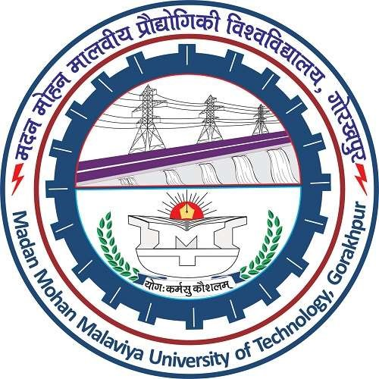Abhinav Kumar Singh

Male, 20

|  |  |  |  |
| --- | --- | --- | --- |
| Academic Record | | | |
| B. Tech (CSE) | 2022 | Madan Mohan Malaviya University of Technology, Gorakhpur |  |
| Class XII | 2017 | Central Academy Sr. Secondary School, Kota(CBSE) | 86.30% |
| Class X | 2015 | Devprayag School & College ,Prayagraj(ICSE) | 92.20% |
| Skills and Tools | | | |
| Skills | Internet of Things, Machine Learning, Data Science, Photoshop and Public Speaking | | |
| Tools | Python, C, C++, Java, Arduino, Linux-Ubuntu and Raspbian, Microsoft Office | | |
| Achievements and Certifications | | | |
| Achievements | * CTO of Codebugged (A promising Startup) * HackerRank Highest Rating: 853 (handle: the_abhi9 ) . * Finalists in wired and wireless robotics competition organized by IEEE Student Branch,techsrijan | | |
| Certifications | * Certified in Machine Learning from Indian Institute of Technology, Kanpur. * Certified in Programming using Python from Microsoft (MTA). | | |

|  |
| --- |
| Internship |
| Nil |
|  |

|  |
| --- |
| Projects |
| * Facial Recognition attendance System – A project on Image processing and Artificial Intelligence using Python framework * Artificial Intelligence System to increase yield in Production of Crop – This project aims at monitoring plant’s growth and then detect best favorable conditions for its growth. It is a project on IoT and Artificial Intelligence. * Digit Recognition using SK Learn – This project aims at optical digit recognition based on Machine Learning technique. ▪ Face and Eye Recognition using Haar-cascades – A simple project using pre built AI to detect Face and Eye of Human ▪ Automatic table lamp using ESP-8266 – Automatic detection of Object and hence switching on-off the table lamp. * Anti-theft Device – An IoT based anti-theft device which could notify activities in almirahs, drawers and safes. |
| Workshops attended |
| * Ethical hacking workshop organized by IEEE, MMMUT Chapter – Learnt about basics of Cybersecurity and Kali Linux * Android app development workshop organized by IEEE, MMMUT Chapter – Learnt about Android Studio * Aeromodelling workshop organized by SAE Collegiate Club, MMMUT – Made an RC Aircraft Working Model * Machine Learning Workshop organized by University Innovation Cell – Learnt about structured data, numpy and scikit. |
| Positions of Responsibility |
| * Executive Member of the IEEE Student Branch, MMMUT Chapter. * CTO of a promising startup CODEBUGGED * Member of the Organizing Committee of TechSRIJAN’19- the techno-management fest. |
| Extra-Curricular Achievements |
| * Leading a student researcher group in MMMUT titled codebugged, We are committed towards development in IoT/ML * 2nd runner up in Pixels a photography event |
| Hobbies |
| Playing Piano, Writing Articles, Debate and Public Speaking |